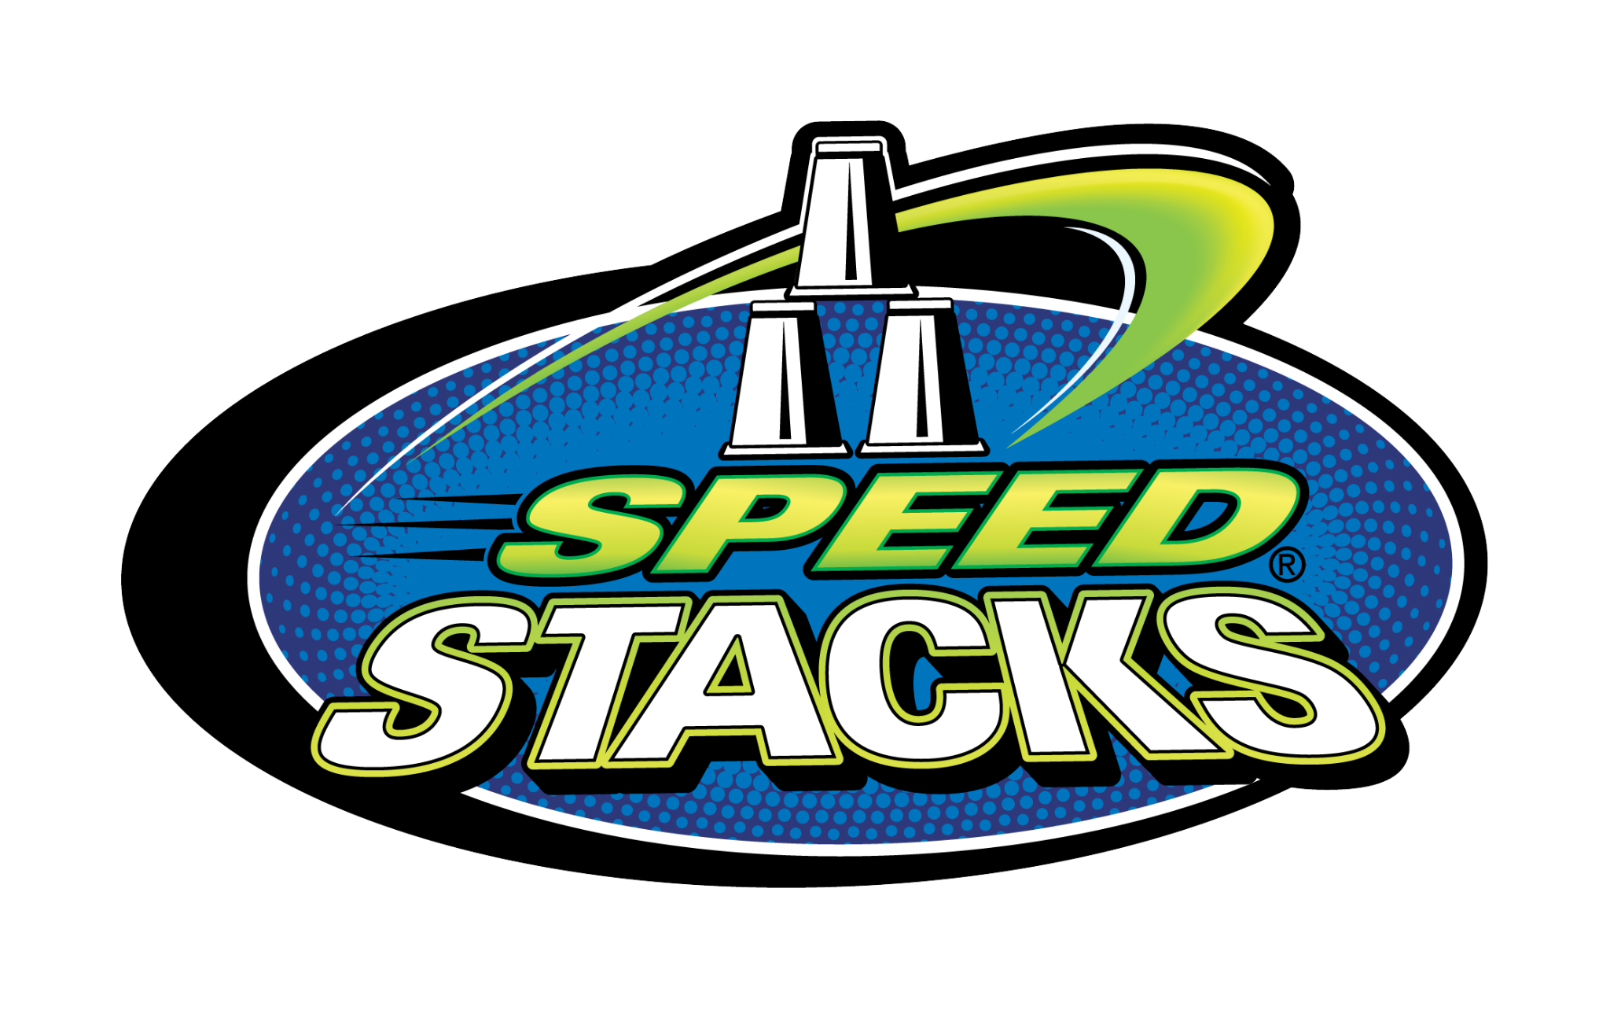
Speed Stacks // Instructor Order Form
Item # | Item | Qty | Price | - - |  | Total
04115 | G5 Sport Stacking Program – 30 Set Sport Pack with 36 Jumbos |  | $650.00 | - -
04114 | G5 Sport Stacking Program – 15 Set Sport Pack with 36 Jumbos |  | $550.00 | - -
04105 | Sport Pack case only, up to 15 sets |  | $34.99 | - -
04106 | Sport Pack case only, up to 30 sets |  | $39.99 | - -
- - | SKILLASTICS – Speed Stacks |  | $280.00 | - -
Item # | Item | Qty | Price | Replacement Cups |  | Total
 |  |  |  | Qty | Price
14402 | Really Red |  | $24.99 |  | Free
14404 | Royal Purple |  | $24.99 |  | Free
14406 | Cool Blue |  | $24.99 |  | Free
14407 | Neon Pink |  | $24.99 |  | Free
14408 | Neon Orange |  | $24.99 |  | Free
14409 | Neon Yellow |  | $24.99 |  | Free
14410 | Neon Green |  | $24.99 |  | Free
14419 | Black Flame |  | $24.49 |  | Free
14420 | Zippy Leopard |  | $24.49 |  | Free
02620 | Pro Series 2x - Metallic Orange |  | $34.99
- - | Snap Tops |  | $5.99 | - -
02100 | Cup Keeper |  | $0.99 | - -
05011 | Red/White/Blue Mini Set |  | $9.99 |  | $1.50
03809 | Jumbo Stacks |  | $215.00 |  | $5.99
13400 | G5 StackMat PRO (Timer & Mat) |  | $34.99 | - -
03400 | G5 Mat Only |  | $14.99 | - -
03017 | G5 PRO Timer (Timer Only) |  | $24.99 | - -
03305 | Tournament Display PRO |  | $109.99 | - -
Sub Total:
CALIFORNIA ONLY – multiply line above by 0.085 and enter that amount here for sales tax:
Add $10.00 shipping fee for orders below $100.00. Free shipping for orders above $100.00: |  |  |  |  |  | $10.00
(add the two lines above to the sub total) Grand Total:

Order Information:
Person Ordering: |  | Title: |  | Date:
Tax Exempt #: |  |  |  | PO #:
School / Org Phone: |  | Fax: |  | Email:
Billing Address: |  |  | Shipping Address:
School / Org: |  |  | School / Org:
Attn: Phone: |  |  | Attn: Phone:
Street: |  |  | Street:
City: State: Zip: |  |  | City: State: Zip:
Speed Stacks, Inc. 15550 Arfsten Rd, Larkspur, CO 80118 // 877-468-2877 // info@speedstacks.com

